Chapter 8, Problem 35.

Using Fig. 8.83, design a problem to help other students better understand the step response of series RLC circuits.
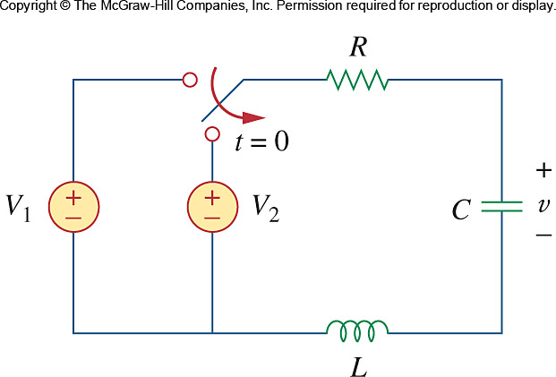

Figure 8.83
For Prob. 8.35.

